**Title:** *Landscape context mediates the effect of shortening fire intervals on successional trajectories in boreal systems*

**Abstract:**

Warming temperatures in the boreal have increased the frequency and severity of wildfires, causing time intervals between fires in some areas to decrease from 50-100 years to 10-15 years within the last three decades. Shortening fire intervals have been shown to drive changes in successional pathways in boreal forests via seedbank limitation, but the extend of those changes and the role of variability in topography in promoting successional divergence remains unclear. While postfire succession in upland boreal black spruce forests is well understood, the effect of varying topography on the impact of multiple short-interval fires remains unclear. To investigate how landscape variability alters postfire successional trajectories under shortening fire intervals, we established plots across a mosaic of fire histories (1-3 fires in 70 years) in two sites in Interior Alaska with differing hydrology. We compared regeneration of conifers, deciduous trees and shrubs, and graminoids as well as soil carbon and nitrogen across unburned controls and stands experiencing one, two or three fires in 15-year intervals in an upland site (drier) and a lowland site (wetter). All stands were originally dominated by black spruce (*Picea mariana*), and at both sites, black spruce regeneration was significantly lower following three fires, compared to unburned stands and stands burned once. In the wetter lowland site, less organic soil was consumed by fire and presence of black spruce persisted until two fires, indicating local topography may initially drive successional divergence via differences in substrate consumption. Deciduous regeneration differed between two sites after three fires, with paper birch (*Betula neoalaskana*) dominating in upland sites and willow (*Salix spp.)* and aspen (*Populus tremuloides*) in lowlands. Results of this study offer strong empirical evidence of the divergence of boreal successional trajectories from previous historic norms and indicate the importance of examining the role of spatial heterogeneity on the impact of multiple disturbances.

**I. Introduction**

Increasing temperatures have been linked with global increases in the frequency and intensity of wildfires, sparking concern that changing fire regimes will lead to rapid ecosystem change if local resilience is exceeded (Young et al. 2017). Fire-free intervals in boreal systems have shrunk rapidly, and modern fire frequency in areas such as Interior Alaska is higher than in all 3 ka years of the paleoecological record of modern boreal forest history (Kelly et al. 2013). Fire return intervals of < 20 years have become increasingly common across the last six decades (Kasischke et al. 2010, Brown & Johnstone et al. 2012, Johnstone & Chapin 2006, Johnstone & Chapin 2006). Short fire intervals (< 30 by boreal standards) have been shown to alter successional pathways through seedbank (Brown and Johnstone 2012, Johnstone et al. 2004) and substrate consumption (Hesketch et al. 2009), and theoretical model outputs suggest that an increase in area reburned in short intervals may lead to a shift in forest community composition from conifer-dominated stands to deciduous shrublands and grasslands (Johnstone et al. 2009, Hoy et al. 2016). Initial empirical observations of reburning in the boreal system indicate an increased presence of deciduous species after the second fire alongside a decline in conifers, but to date research has been limited to single reburn events (2 fires in sequence). While this is valuable, an increase in fire frequency means repeated short interval events – and the cumulative effects of three or more fires - remains unknown, limiting our ability to make inferences regarding future boreal forest community composition. There is no information on how boreal forested ecosystems respond to such an acceleration of fire. Furthermore, research on short interval fires has almost entirely focused on conifer resilience, but the effects of short interval fires on deciduous species is unknown. Given the increasing evidence for a shift to a boreal forest dominated by deciduous species, understanding the effects of multiple fires on the emerging deciduous-dominated forest structure will be essential to understanding and predicting the impact of ongoing environmental and climatic change in high-latitude environments (Johnstone et al. 2011, Brooks et al. 2004, Rupp et al. 2011).

Conventional understanding of secondary successional trajectories in serotinous boreal systems identifies self-replacement as the most prevalent post-fire successional pathway: black spruce (*Picea mariana*) typically self-replaces after fire, remaining the dominant canopy cover before and after disturbance (Kurkowski et al. 2008). This self-replacement is driven by black spruce reproductive capabilities: the species has high resilience to fire via a serotinous canopy seedbank, resulting in dense regeneration within 10-13 years postfire (Johnstone et al. 2004). Often referred to as a “legacy lock”, the black spruce serotinous strategy means the species maintains ongoing and persistent canopy coverage throughout traditional intervals of fire (Johnstone et al. 2010). However, serotinous regeneration strategies have been shown to become more vulnerable under increasing short-interval fires in other systems (Buma et al. 2013). Furthermore, species distribution models have shown that the climatic niche conditions satisfying physiographic requirements of both black spruce and deciduous species may expand with warming temperatures, potentially creating more opportunities for successional divergence (Kurkowski et al. 2008). The interval squeeze caused by a combination of changing demographic envelopes and shortening fire intervals may make black spruce increasingly vulnerable to local extirpation, allowing for deciduous species to become dominant (Enright et al. 2015).

Signs indicate the species-replacement post-fore successional pathway has already become more common: the transition of dominance from conifers to birch and other deciduous species following two consecutive fires has been well documented in Interior Alaska (Johnstone et al. 2004, CITE), the Yukon Territory (Brown, Whitman et al. 2018), Eastern Canada (Bergeron et al. 2012) and Northern Minnesota (CITE). This empirical work has emphasized the importance of reburning consuming serotinous seedbanks in particular, thereby limiting serotinous regeneration within the first 5-10 years postfire.

Rapidly increasing fire frequency has effects beyond the direct depletion of the canopy seedbank. The role of burn severity in promoting deciduous dominance through consumption of soil organic layer has been well documented in boreal Interior Alaska, but primarily in the gently sloped upland environments typical in the Interior (Gibson et al. 2016, Houle et al. 2017). Successional trends in flatter, wetter lowland sites remain underexamined, though they represent 42% of the boreal Interior area (Douglas et al. 2014, Jorgensen and Shur 2007). Their under-examination in comparison to upland sites may be in part because of the historic unlikelihood of lowlands burning. Given warming temperatures, lowland sites may begin burning more frequently, making it crucial to understand postfire successional trajectories in lowland sites. Furthermore, soil moisture may have important role in mediating the effects of fire on successional pathways in wetter lowland sites, providing a potential resilience mechanism for black spruce stands (Houle et al. 2017).

This study characterizes post-fire regeneration following a rapid increase in fire frequency from the 1940s to present. We compare forest resilience across a gradient of 1-3 fires in both upland and lowland forests. We hypothesize that repeat, short interval fires will reduce conifer abundance via a reduction in the seedbank and organic layer thickness, favoring deciduous trees, as shown in other systems – but that continued short interval fires will similarly disfavor traditional secondary succession communities in favor of primary succession communities. We anticipate that dry, sloped sites may be less resistant to this transition due to greater soil consumption in each fire. We test those hypotheses by A) comparing patterns of postfire regeneration across a range of fire histories within a single pre-fire forest type in upland and lowland sites and by B) linking soil organic layer characteristics to the relative abundance of plant regeneration patterns by species. Our results provide an empirical test of the resilience of black spruce forest communities in uplands and lowlands to shortening fire intervals.

**II. Methods**

**Site Selection**

We established 50 individual 20x20m plots across two locations in Interior Alaska in natural mosaics of stands differing in recent fire history. Each plot experienced between one to three fires in the last 60 years, with the final burn in XXX-XXX. Eight unburned plots were established as controls (total n=58).

Site History: On all plots, vegetation was dominated by black spruce (scientific name) before the first fire with occasional birch (scientific name) or trembling aspen (scientific name), and in mature stands the mineral soil is covered with a thick moss mat (mean depth XX +/- X). Presence of spruce prior to the burn sequence was established from modern remotely sensed landscape cover data where and when available (Supplement 1), and ground-truthed by sampling XXX downed woody debris of various ages. Fire severity has a well-documented role in post-fire forest community composition in the boreal (Hollingsworth et al. 2013). To control for fire severity, all plots experienced full canopy mortality during each fire, as identified by aerial photography and remotely sensed fire perimeters.

Site Locations: Plots were randomly placed within the various burn histories, with a minimum of 50 meters spacing and a minimum of 50 meters away from unburned legacies. Plots were stratified evenly between an upland site and a lowland site. The upland site represents well drained boreal forest; the lowland a flatter, more poorly drained location. Both are on the northern edge of the discontinuous permafrost zone; with nearby unburned black spruce communities have shallow permafrost in both locations (data not shown).

Individual plots were established across a range of slopes and aspects (Fig. X). Upland plots receive an average of XX inches of rainfall per year, while lowland plots receive XX. Size of plots, slope and aspect taken from XX source.

[Soil paragraph]

**Field Sampling**

Stems and seedlings were counted in each plot; where density precluded counting over the entire 400m2, a randomly selected subset (100 or 200 m2) was counted. Canopy health, presence of browse, and understory species were noted for each stem counted above DBH. For asexual reproducers such as willow and aspen, each individual stem in a given clump was counted and then clumps were pooled and treated as individuals.

Distance from adventitious roots to soil surface was measured were snags were available to sample. Maximum distances were recorded for all adventitious roots found.

Organic layer depth was measured at the center and at each corner of each plot.

Presence and abundance of soil cover was estimated across 1-meter subplots at each corner of each site, along with presence and abundance of understory species.

**Data Analysis**

We used LME models to determine the effect of substrate consumption on regeneration abundance of each species. Each model included an interaction between the fixed effects of fire history and site. The best structure for each model was selected based on the lowest AIC value and F-test comparisons (Table #).

All analyses were performed in R version (CHECK) (R Development Core Team, 2014) and reported means include +/- 1 standard error. Generalized mixed-models were conducted through ‘lme4’ (Bates et al. 2019). Figures were created through ‘ggplot2’ (Wickham 2018) and ‘cowplot’ (Wilkes et al. X). All dependent variables were log-transformed to meet assumptions of normality. Because our plots are clustered by design to take advantage of natural experimental conditions, spatial autocorrelation among plots was assessed by [EXPLAIN]. We found no evidence of spatial autocorrelation (Table #) but accounted for the grouping of plots in sites by including site as a random effect in linear mixed effect models (LME).

**III. Results**

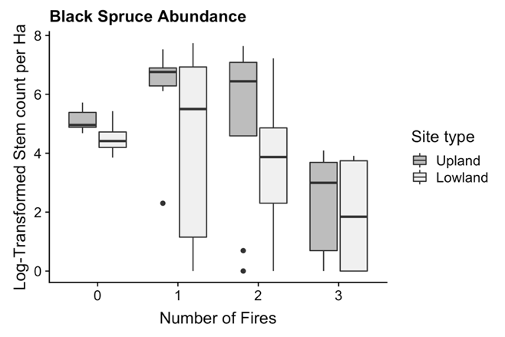

**Figure X. Density of black spruce seedlings and established trees according to number of fires.**

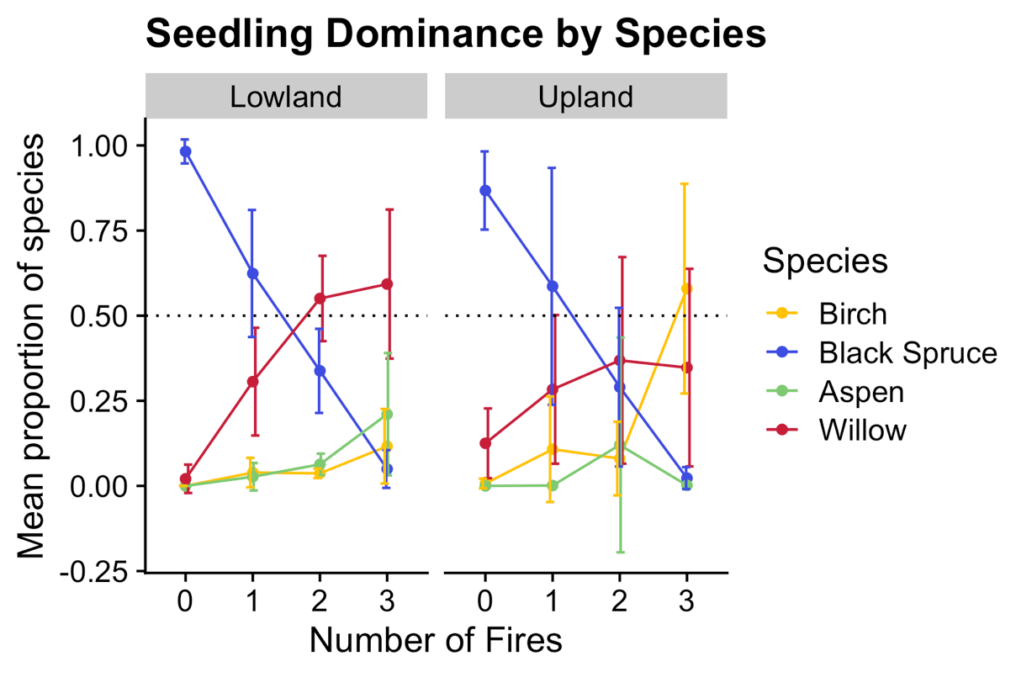

**Figure X. Average proportion of species present at each burn history between upland and lowland sites. Error bars represent standard deviations**

**Seedling regeneration**

Black spruce is the dominant seedling present in unburned plots, representing 98% of upland seedling species and 86% of lowland seedling species. Density declines with increasing number of fires to X% and X% in uplands and lowlands respectively. Willow seedling dominance increases across fire history in both sites initially, but a divergence occurs between upland and lowland plots after two fires: willow assumes dominance in twice- and thrice-burned lowland plots but willows never represent more than 50% of seedlings in upland sites, and in fact declines between twice- and thrice-burned plots. Proportions of birch seedlings increase significantly (p-value = X) between twice- and thrice-burned upland plots by a factor of X.

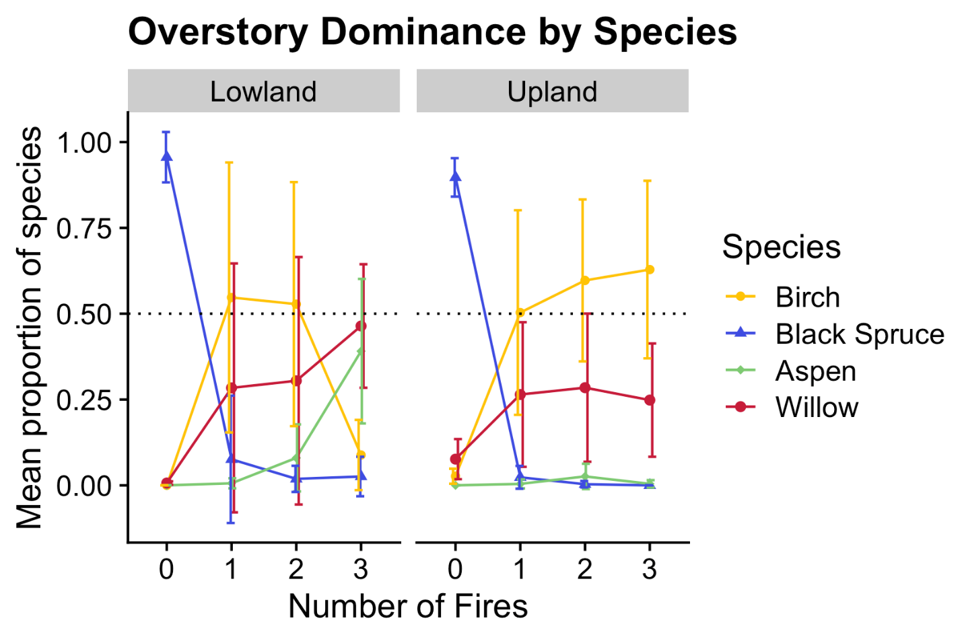

**Figure X. Average proportion of individual species above DBH height across each fire history between upland and lowland sites. Error bars represent standard deviations.**

**Overstory Dominance**

In unburned sites in both upland and lowland plots, the dominant canopy species is black spruce, with minimal relative presence of birch or willow. Black spruce dominance decreases significantly after one fire in both upland (insert p-value) and lowland plots (p-value = 1.624e-05). Upland plots see an increase in the proportion of birch, willow and alder after two fires, with birch assuming dominance (representing more than 50% of the species present on a plot) after three fires. Lowland plots see a similar increase in birch and willow, with willow and poplar becoming dominant after the third fire (Figure X). Birch presence in lowland plots is significantly different between twice- and thrice-burned plots (p-value), decreasing in proportion by a factor of X.

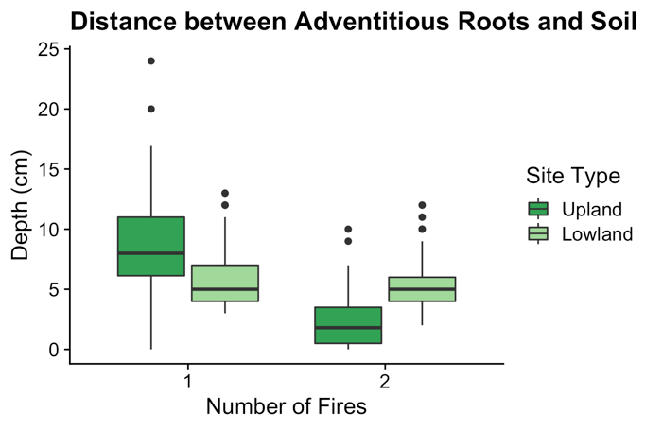

**Figure X. Distance in centimeters between highest adventitious black spruce roots to soil surface across fire history.**

**Adventitious roots**

Adventitious roots were only available to sample in once- and twice-burned plots. Depth from adventitious root to current soil surface ranged from 0 to 24 cm in once-burned upland plots, and 3 to 7 cm in once-burned lowland plots. The range of adventitious root depth in upland plots shrank between once- and twice-burned plots by a factor of 2.4. Adventitious root depth in lowland plots did not differ significantly (p-value = 0.1064) between once-burned and twice-burned plots.

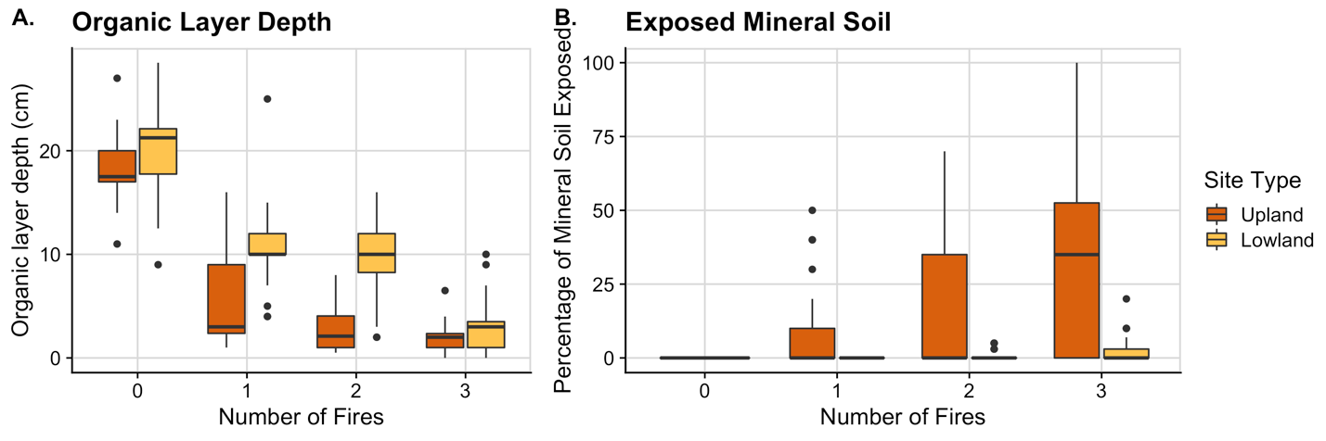

**Figure X. A) Depth of Organic Layer (cm) between Upland and Lowland Sites according to burn history. B) Percent cover of exposed mineral soil in Upland and Lowland sites across burn history.**

**Soil Consumption**

Unburned organic-layer depths ranged from 11 to 27 cm in upland plots and from 9 to 28.5 cm in lowland plots with respective averages and standard deviations of 18.35 cm +/- 3.4 cm and 20.2 cm +/- 4.5 cm. In once-burned sites, organic-layer depths ranged from 1 to 16 cm in uplands and from 4 to 25 cm in lowlands, averaging 5.7 +/- 4.7 cm and 10.91 +/- 3.6 cm respectively. Twice-burned plots had upland organic-layers between 0.5 and 8 cm deep and lowland layers between 2 and 16 cm with averages of 3 +/- 2.2 cm and 9.8 +/- 4 cm. Finally, thrice-burned organic-layers fell between 0 and 6.5 cm in uplands and 0 and 10 cm in lowlands, averaging 1.9 +/- 1.4 cm and 2.9 +/- 2.3 cm. Lowland organic-layers were thicker than upland layers regardless of burn history by a factor of 1.6, and the difference between the two sites was largest in twice-burned plots where lowland organic-layers were larger by a factor of 3.2. Upland plots had no exposed mineral soil in unburned sites, but saw an increased in the amount of exposed mineral soil, up to 100% in some thrice-burned plots.

**Model Results**

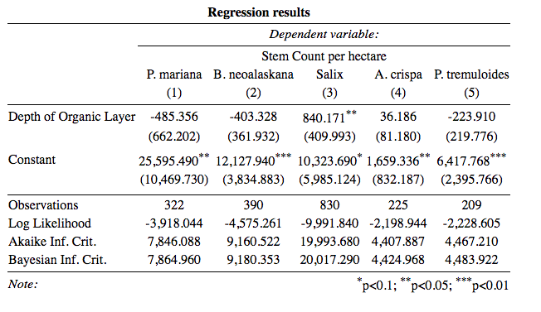

Results from the linear mixed model indicate a significant association between organic layer depth and black spruce regeneration after controlling for the variation found between number of fires and site (p-value = < 2e-16).

**Discussion**

**Seedling Regeneration**

The majority of black spruce recruitment has been found to take place within 3 to 10 years after fire, indicating our results should capture the full extent of black spruce reestablishment (Johnstone et. al 2004). Furthermore, studies like Johnstone et. al 2004 have found that stand composition 5 years postfire is strongly predictive of composition 20 to 30 years out, indicating the importance of initial recruitment rates and trends in determining decadal successional pathways. Seedling composition of our plots 15 years postfire may therefore be taken as strongly inferential of future stand compositional communities. Comparing our seedling recruitment trends to those found in single postfire successional studies, or even single reburn successional studies, the decline in black spruce found in short-interval reburns becomes especially dramatic: Johnstone et. al 2004 found black spruce to be 98% of all postfire tree seedlings after a single fire, with stem densities between 1-9 stems per square meter [Double check if stems or seedlings]. Our seedling densities in once-burned plots are similar, but soon plummet to densities <1 seedling per square meter in thrice-burned plots, with stem densities of zero occurring by the same number of fires. This sharp decline in abundance of both black spruce seedlings and established trees is clear empirical evidence of short-interval fires reducing serotinous seedbanks and therefore populations.

**Overstory Regeneration paragraph**

**Soil Consumption**

The divergent trend in organic layer consumption indicates the difference in fire effects between the upland and lowland sites: less organic layer is consumed in lowland sites with one or two fires, indicating that wetter conditions may mediate the effect of even high-severity fires. Furthermore, upland sites had significantly more mineral soil exposed in burned sites, even with substantial within-treatment variation. This variation between sites indicates that local heterogeneity in topography and climate may facilitate resilience in black spruce stands, up until a certain threshold.

Our regeneration results indicate a boreal forest successional trajectory diverging from patterns of the past. The abundance of black spruce in burned plots is low enough to suggest the prevention of self-replacement as a future successional pathway in those specific sites. Furthermore, deciduous species are emerging in assemblages novel to Interior Alaska boreal forests: the strong presence of willow and aspen in particular indicate the emergence of not only a species-replacement successional trajectory, but a species-replacement successional trajectory much more in line with primary successional trends than secondary.

Within the broader context of fires in the boreal, these results indicate that multiple short-interval fires may reduce serotinous conifer populations, allowing for the emergence of woodlands or shrublands dominated by deciduous species. Wetter lowland forests may be initially more resistant to this transition, given the mitigating effects of soil moisture, but that resilience may be overcome by subsequent fires.

**References**

Bergeron, Yves, and Nicole J. Fenton. "Boreal forests of eastern Canada revisited: old growth, nonfire disturbances, forest succession, and biodiversity." *Botany* 90.6 (2012): 509-523.

Douglas, Thomas, et al. "Sources and sinks of carbon in boreal ecosystems of interior Alaska: A review." *Elem Sci Anth* 2 (2014).

Hollingsworth, T.N., Johnstone, J.F., Bernhardt, E.L. and Chapin III, F.S., 2013. Fire severity filters regeneration traits to shape community assembly in Alaska’s boreal forest. PloS one, 8(2), p.e56033.

Houle, G.P., Kane, E.S., Kasischke, E.S., Gibson, C.M. and Turetsky, M.R., 2017. Recovery of carbon pools a decade after wildfire in black spruce forests of interior Alaska: effects of soil texture and landscape position. Canadian Journal of Forest Research, 48(1), pp.1-10.

Hoy, Elizabeth E., Merritt R. Turetsky, and Eric S. Kasischke. "More frequent burning increases vulnerability of Alaskan boreal black spruce forests." Environmental Research Letters 11.9 (2016): 095001.

Kasischke, Eric S., and Merritt R. Turetsky. "Recent changes in the fire regime across the North American boreal region—Spatial and temporal patterns of burning across Canada and Alaska." Geophysical research letters 33.9 (2006).

Kelly, Ryan, et al. "Recent burning of boreal forests exceeds fire regime limits of the past 10,000 years." Proceedings of the National Academy of Sciences 110.32 (2013): 13055-13060.

Kurkowski, Thomas A., et al. "Relative importance of different secondary successional pathways in an Alaskan boreal forest." Canadian Journal of Forest Research 38.7 (2008): 1911-1923.

**[Table of fires, dates, sizes (might do as sites, with the associated fire at each site)]**

|  |  |  |  |  |  |  |
| --- | --- | --- | --- | --- | --- | --- |
| Setting | Treatment | Species | Seedling Density | Seedling SD | Stem Density | Stem SD |
| Lowland | 0 | Aspen | 0 | 0 | 0 | 0 |
|  |  | Birch | 0 | 0 | 0 | 0 |
|  |  | Black spruce | 1.6225 | 0.605 | 0.97 | 0.42559762 |
|  |  | Willow | 0.0275 | 0.055 | 0.0075 | 0.005 |
|  | 1 | Aspen | 0.471428571 | 0.670110154 | 0.00166667 | 0.00408248 |
|  |  | Birch | 0.742857143 | 0.752456295 | 0.09166667 | 0.09780934 |
|  |  | Black spruce | 9.571428571 | 4.623748222 | 0.00833333 | 0.02041241 |
|  |  | Willow | 5.342857143 | 3.859990131 | 0.025 | 0.01843909 |
|  | 2 | Aspen | 2.033333333 | 1.540995349 | 0.01 | 0.00774597 |
|  |  | Birch | 0.966666667 | 0.27325202 | 0.07916667 | 0.05774224 |
|  |  | Black spruce | 10.36666667 | 6.321286789 | 0.0025 | 0.0041833 |
|  |  | Willow | 15.43333333 | 5.153122031 | 0.12 | 0.24091492 |
|  | 3 | Aspen | 1.9 | 1.089342309 | 0.266875 | 0.19484311 |
|  |  | Birch | 0.728571429 | 0.540722621 | 0.04 | 0.03664502 |
|  |  | Black spruce | 0.342857143 | 0.161834719 | 0.00375 | 0.00443203 |
|  |  | Willow | 7.985714286 | 7.635318935 | 0.246875 | 0.16881811 |
| Upland | 0 | Aspen | 0 | 0 | 0 | 0 |
|  |  | Birch | 0.0075 | 0.015 | 0.015 | 0.00912871 |
|  |  | Black spruce | 0.675 | 0.19485037 | 0.6575 | 0.33819373 |
|  |  | Willow | 0.11 | 0.111654228 | 0.05125 | 0.03727712 |
|  | 1 | Aspen | 0.028571429 | 0.075592895 | 5.00E-04 | 0.00158114 |
|  |  | Birch | 4.164285714 | 6.644842253 | 0.208 | 0.32975749 |
|  |  | Black spruce | 10.45 | 8.421698166 | 0.0065 | 0.01546501 |
|  |  | Willow | 8.957142857 | 10.43118037 | 0.1 | 0.13274872 |
|  | 2 | Aspen | 0.065 | 0.11351526 | 0.010625 | 0.01781602 |
|  |  | Birch | 0.91875 | 1.469095324 | 0.300625 | 0.28895671 |
|  |  | Black spruce | 2.45 | 4.66268776 | 0.000625 | 0.00176777 |
|  |  | Willow | 4.7575 | 5.487551497 | 0.123125 | 0.17854446 |
|  | 3 | Aspen | 0.003333333 | 0.008164966 | 0.00166667 | 0.00408248 |
|  |  | Birch | 5.065 | 9.584898017 | 0.49583333 | 0.64749839 |
|  |  | Black spruce | 0.153333333 | 0.232005747 | 0 | 0 |
|  |  | Willow | 0.7 | 0.670134315 | 0.10166667 | 0.06524314 |